neu_seal_cmyk_b.eps

January 25, 2012

The Honorable Janet Napolitano

Secretary of Homeland Security

U.S. Department of Homeland Security

3891 Nebraska Avenue, NW

Washington, DC 20008

Dear Secretary Napolitano:

As leaders of twelve research universities around the country, we write to express our strong support for maintaining the federal investment in homeland security research within the DHS Science and Technology (S&T) Directorate. We are deeply concerned by Congress’ decision to reduce the Fiscal Year 2012 S&T Research, Development and Innovation budget by 54 percent, as well as the adverse impact of sequestration under the Budget Control Act of 2011 on homeland security research.

As you know, S&T is the primary federal research and development agency charged with creating new technologies to guard against terrorist attacks and disasters. Of particular importance to our institutions, S&T collaborates with university partners to protect our nation’s ports, coasts, borders and transportation infrastructure, prevent terrorist and cyber attacks, and help make our communities more resilient. While S&T pursues research on technologies similar to those developed by the military, homeland security end-user needs are sufficiently different and require separate development.

An essential component of S&T’s mission is basic research, which will lead to critical breakthroughs in national security. In addition, the University Programs Centers of Excellence initiative, through which universities undertake applied research on a fast-turnaround basis, has demonstrated a significant positive return on investment. In conjunction with industry partners and national laboratories, university contributions in developing new security technologies – from advances in explosives detection to development of underwater sensors to mitigating the effects of natural disasters – argues for additional investment.

We want to work with you to ensure this vital research continues. Although we are cognizant of current budgetary challenges, hobbling S&T is at odds with the targeted investment in innovation necessary to grow our economy. Steep reductions may precipitate private sector job loss and an unacceptable weakening of our nation’s security. We urge you to once again support S&T research in the Department’s forthcoming Fiscal Year 2013 budget submission.

We appreciate your commitment to work closely with universities to engage the next generation of homeland security leaders and better leverage relationships with the academic community. We look forward to working in partnership with you to produce the innovative solutions necessary to preserve our democracy and keep our nation safe.

Sincerely,



Joseph E. Aoun Dennis D. Berkey

President President

Northeastern University Worcester Polytechnic Institute

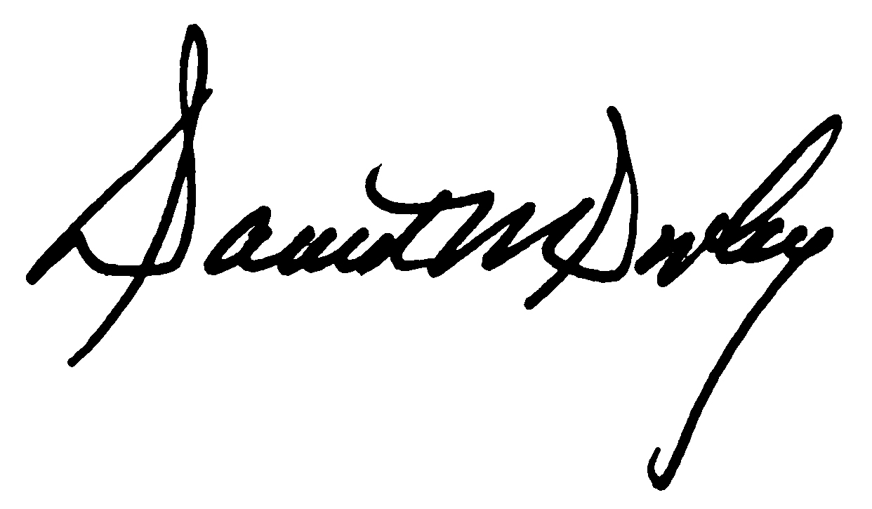

David M. Dooley Jared L. Cohon

President President

University of Rhode Island Carnegie Mellon University

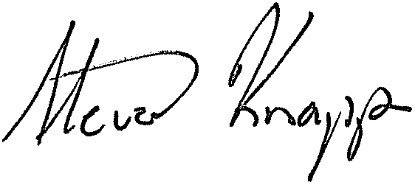

Steven Knapp Eric W. Kanter

President President

George Washington University University of Minnesota

Wallace D. Loh Robert L. Caret

President President

University of Maryland University of Massachusetts



Richard L. McCormick Patrick T. Harker

President President

Rutgers, The State University of New Jersey University of Delaware



Satish K. Tripathi John A. Fry

President President

University at Buffalo Drexel University